
THE CHINESE UNIVERSITY

OF HONG KONG (SHENZHEN)

School of Science and Engineering

Tutorial - 11

Fundamental of Artificial Intelligence CSC3180

- Answer the following questions:

- Why Artificial Neural Network (ANN)? (L12: P4-8)
- What’s ANN? What’s the assumption of ANN (L12: P10-14)? And list some applications of ANN. (L12: P16)
- Please understand some ANN designs (L12: P18)
- What’s the Hebb net? How to optimize the Hebb net? What’s the application? (L12: P30-33)
- What is perceptron learning? Which difference between Hebb net and perceptron? (L12: P35-37)
- What’s BP? Please describe the BP algorithm. (L12: P43-48)

- Set that we have a dataset with 4 samples in two classes just as in the Table 1 and a Hebb net for it just as in Figure 1. Initialize the weight w₁, w₂ and b with 0. Please update the weight with Hebb rule and calculate the weight after training.
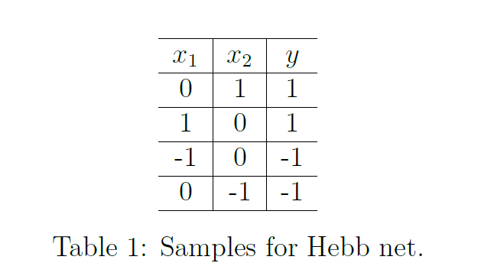
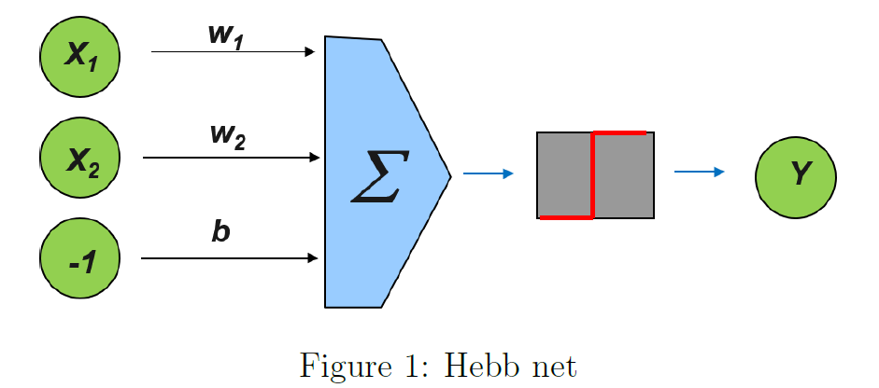

- Table 2 is a dataset with 4 samples in two classes. And a very simple network with only one single neuron is designed to fit y in Figure 2. Initialize the weight w₁, w₂ and b with 0. The loss function is defined as 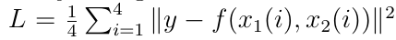. 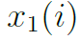 and 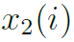 represent x₁ and x₂ in row i of Table 2. Set the learning rate to be 0.1. Please update the weight for 1 iteration with the BP algorithm.

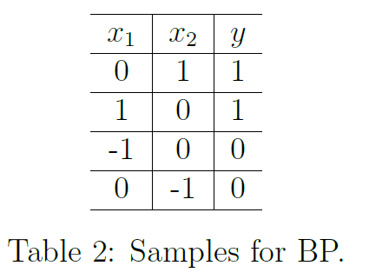
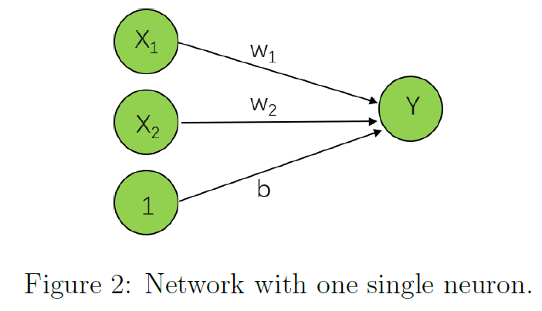

- A neural network with two inputs, x1 and x2, and one output, y, is given in Lecture 12, which has three layers for XOR applications.
- Please understand the three stages: Feedforward, Backpropagation of Error, and Update Weights & Biases.
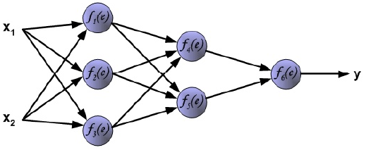
- There are ten characters, A, B, …, J (each 7x9 binary pixels). Please design a neural network which has both 63 input and 63 output layers to implement data compression. Note that the tolerance could be 0.2.
